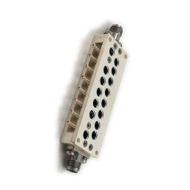Product: Band Pass filter

## Part Number: LBF-33.5/13.5-2S

|  |
| --- |
| Specification |

|  |  |  |  |  |  |
| --- | --- | --- | --- | --- | --- |
| **No.** | **Parameter** | **Minimum** | **Typical** | **Maximum** | **Units** |
| 1 | Center Freq. |  | 33500 |  | MHz |
| 2 | Pass band | 26500 |  | 40000 | Mhz |
| 3 | Insertion Loss at Center Freq. |  |  | 1.0 | dB |
| 4 | Rejection | **≥10dB@20-26Ghz, ≥50dB@DC-25Ghz** | | | dB |
| 5 | VSWR | - |  | 1.6 | - |
| 6 | Power |  |  | 10w | W cw |
| 7 | Operating Temperature Range | -35 | - | +50 | ˚C |
| 8 | Impedance | - | 50 | - | Ω |
| 9 | Connecter | 2.92-F | | | |
| 10 | Preferred finish | Black/sliver/blb | | | |

**Remarks:**

.Power rating is for load vswr better than 1.20:1

|  |  |
| --- | --- |
| Environmental Specifications | |
| Operational Temperature | -35ºC~+60ºC |
| Storage Temperature | -50ºC~+85ºC |
| Vibration | 25gRMS (15 degrees 2KHz) endurance, 1 hour per axis |
| Humidity | 100% RH at 35ºc, 95%RH at 40ºc |
| Shock | 20G for 11msec half sine wave,3 axis both directions |
| Mechanical Specifications | |
| Housing | Aluminum |
| Connector | stainless steel |
| Female Contact: | gold plated beryllium bronze |
| Rohs | compliant |
| Weight | 0.1kg |

Outline Drawing:

All Dimensions in mm

Outline Tolerances ± 0.5(0.02)

Mounting Holes Tolerances ±0.2(0.008)

All Connectors: 2.92-Female

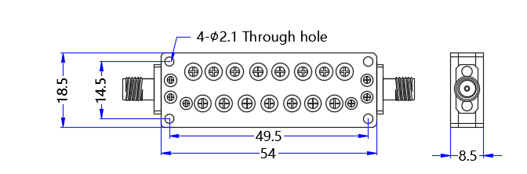

|  |
| --- |
| Test data |

